Centers for Medicare & Medicaid Services

Managed File Transfer (MFT)

Web User Guide
Version: 1.05
04/30/2021
Document prepared by
Document Number: N/A
Contact Number:

Contents
Managed File Transfer (MFT) 1
Web User Guide 1
User Access 3
Dashboard Navigation 4
Folder Access 4
Folder Functions 5
Downloads 6
Share With 6
Send To 8
Navigation Bar 8
Upload 9
New Folder 11
Refresh 12
Share 12
Navigate 13
Mail 13
Inbox 14
Compose 15
Request Files 16
Drafts 16
Templates 17
Outbox 18
Sent Items 18
File Size 19

User Access
Login:
- Web Users: https://qnetmft.cms.gov/mft-signin/login
- Enter your HARP ID
- Enter your HARP password

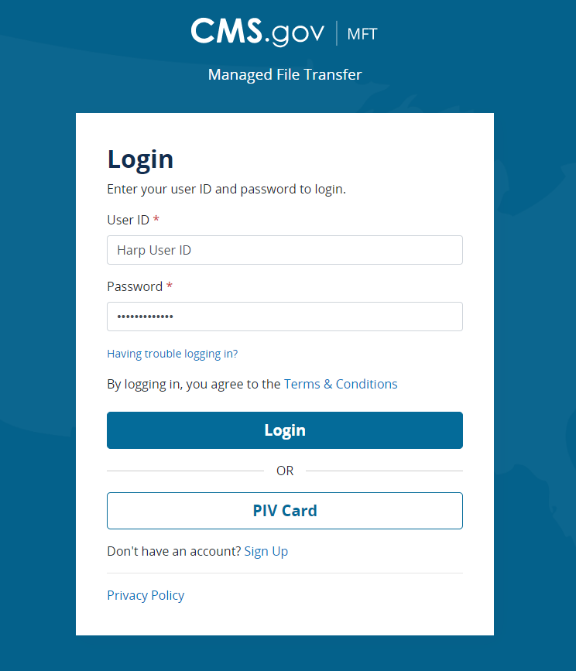

Upon a successful login, you will be redirected to the main dashboard page.
From the dashboard, you will be able to navigate to your folders under your group directory, a shared files folder, the various mail functions and forms.

Dashboard Navigation

Folder Access
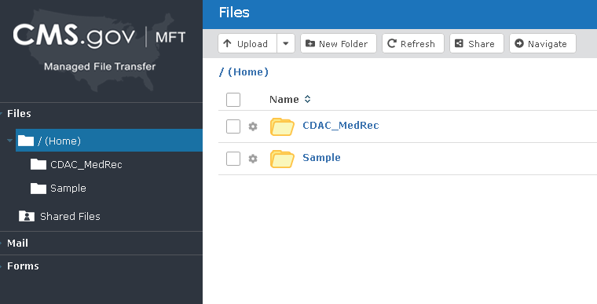
Your file folders are displayed on the left-hand navigation as well as on the main dashboard.
Clicking on a folder in the left-hand navigation will display the contents of the selected folder on the screen.
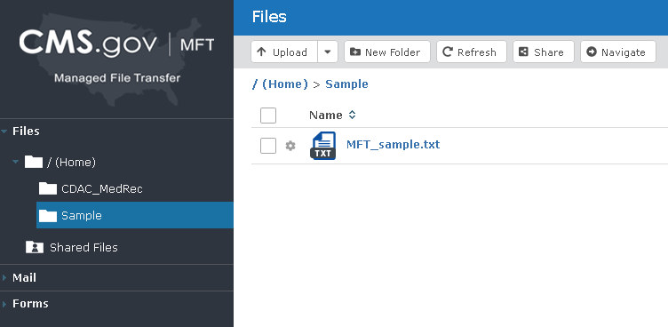

Folder Functions
There are three functions that can be performed on folders by clicking on the gear. They are:
- Download
- Share With…
- Send To…

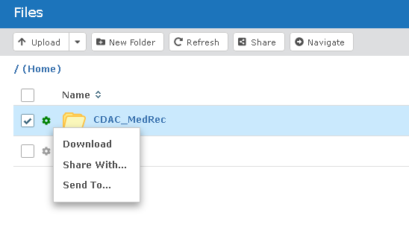

Downloads
Choosing “Download” will allow you to download the contents of the folder as a zip file.
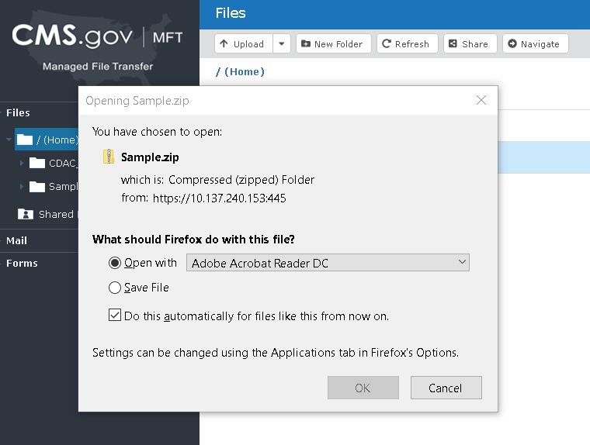

Share With
Sharing a folder will allow others to access it based on the permissions specified that are identified. Any recipients that are not registered will receive an email invite to create an account before they can access this folder.
You will populate the following fields:
- To (Required)
- Subject (Required)
- Message
- Folder
- Share As (Required)
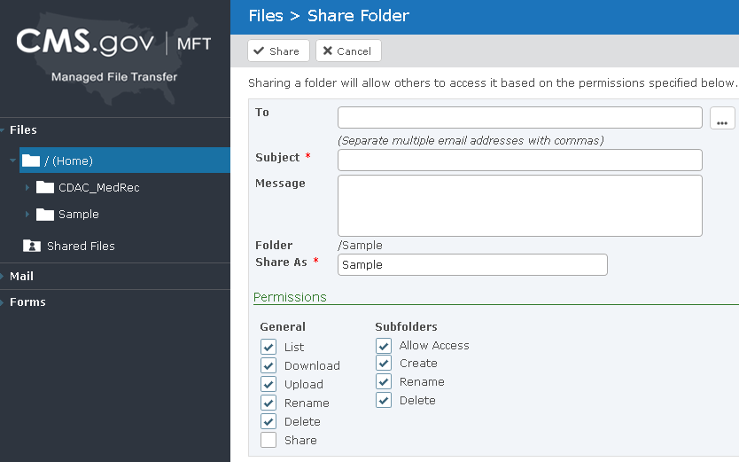
If your permissions are not set by default, ensure the appropriate permissions are selected.

Send To
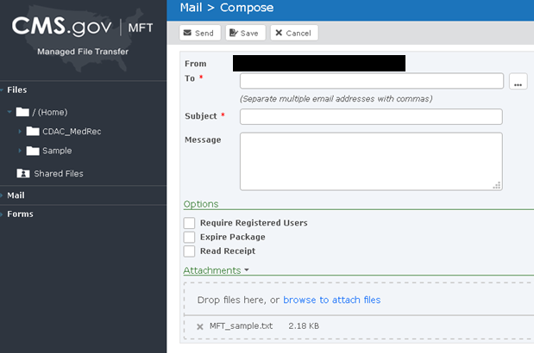
Sharing a folder will allow others to access it based on the permissions specified below. Any recipients that are not registered will receive an email invite to create an account before they can access this folder.
Select the appropriate available options and attach the file(s) to send. Next send, save or cancel your request.
Note: Recipients of PHI / PII must be onboarded to MFT and senders may not utilize non-registered user option when sending PHI / PII.

Navigation Bar
There are five functions available from the navigation bar. They are:
- Upload
- New Folder
- Refresh
- Share
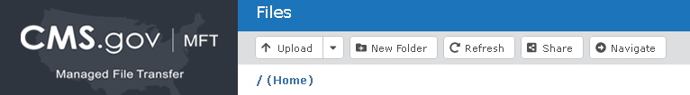
- Navigate

Upload
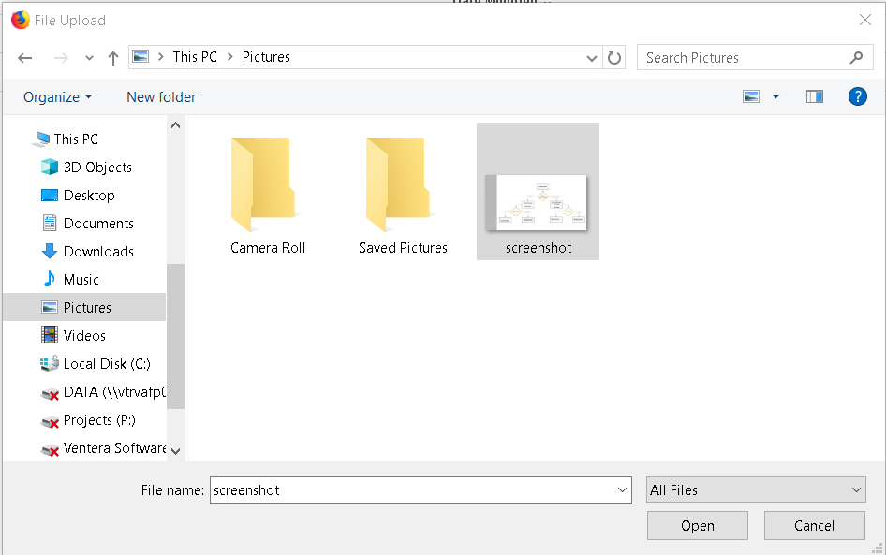
Click on the upload button to perform a file upload. The File Upload dialog box will open; choose your file to upload and click “Open.” You can upload multiple files simultaneously.

Once you have uploaded your file, you’ll see it listed with your other files. If you do not want the file placed in your home directory, select the folder where you want the file(s) placed and then upload.
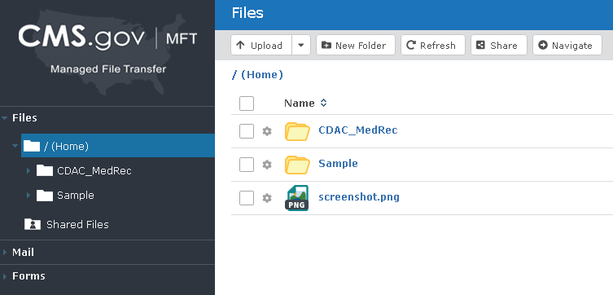
Clicking on the gear will also provide you with an option to rename the file. This is not available on the folder level.
Click on the checkbox for additional options.
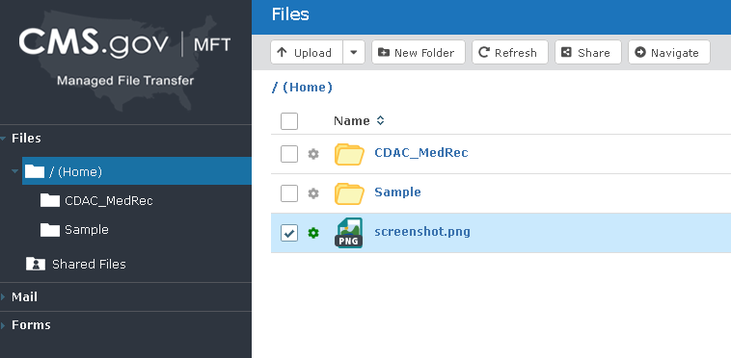
Once a file or folder is selected, you will be provided with the following options:
- Delete – This will delete the file. If a folder is chosen, the all files as well as the folder will be deleted.
- Send To – This functionality works the same as referenced on Page 6.
- Download – This will allow you to download the file or folder as described on Page 5.
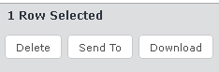

New Folder
This option will allow you to create a new folder within the directory you are currently in. If you want to create a subdirectory, click on the primary folder and then select “New Folder.”
Once selected, a prompt will appear requiring a name for the new folder. Provide a name and click “Create.”
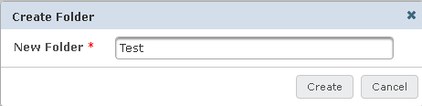

Once created, you will receive a confirmation and will see the new folder in the directory.
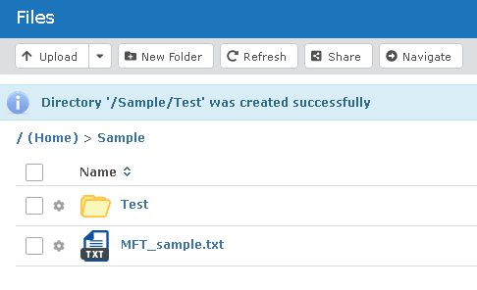

Refresh
This will refresh your current view if there were any modifications while you were idle.

Share
This functionality works as described on pages 5 and 6.

Navigate
This functionality allows you to manually enter a directory path to access.
After clicking “Navigate” enter the directory / file path and hit enter. The screen will then display the contents of that directory.
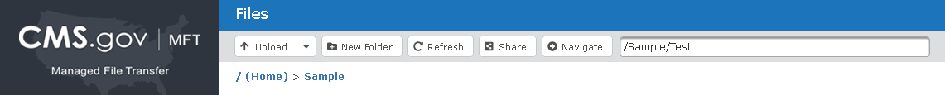

Mail
Managed File Transfer (MFT) provides the ability for the secure transfer of files from one user to another through a network. The mail functions within MFT are as follows:
- Inbox
- Compose
- Request Files
- Drafts
- Templates
- Outbox

Inbox
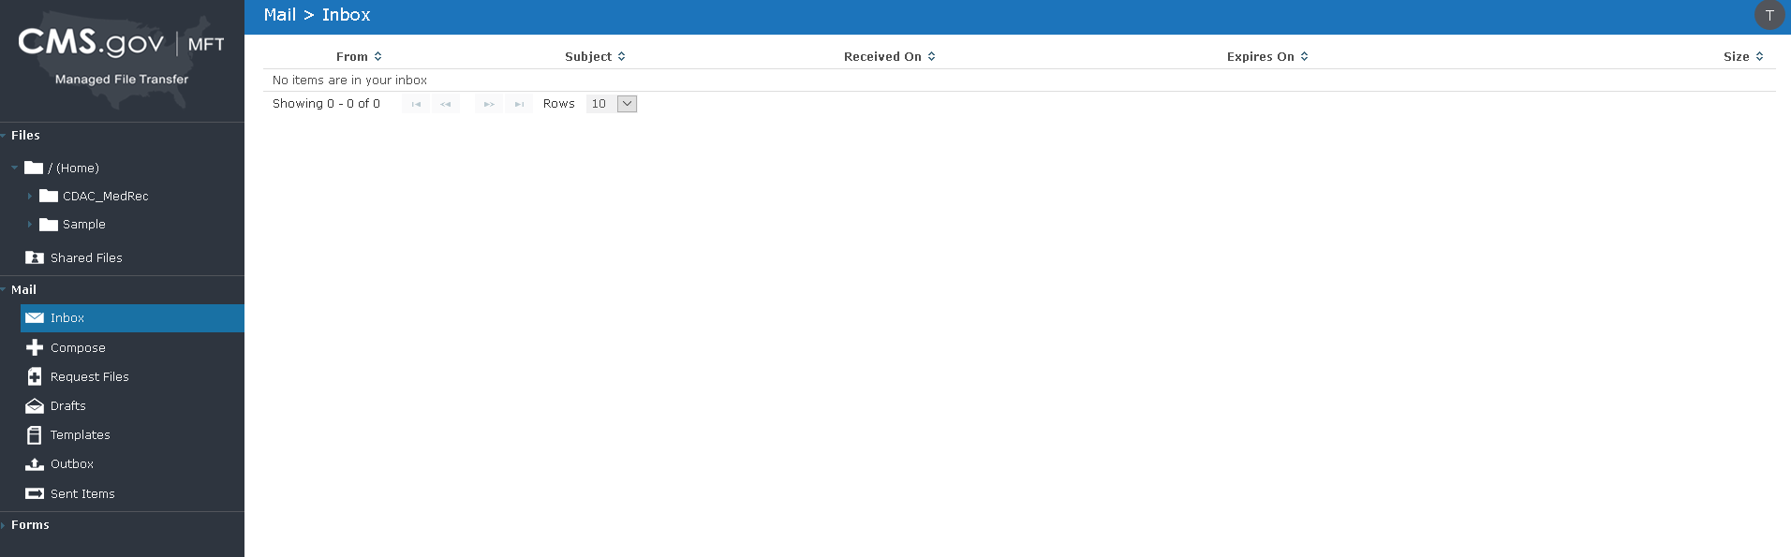
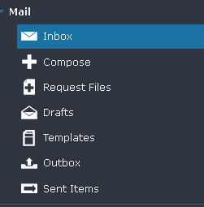
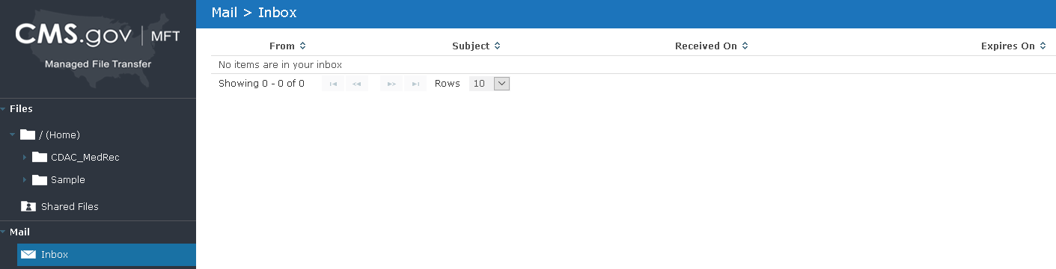
The inbox will display any messages that were sent to you by users. The inbox displays who the message is from, the subject, when it was received, when it expires and the size of the message.

Compose
Click “Compose” to compose a message. Once selected, you will see the following screen:
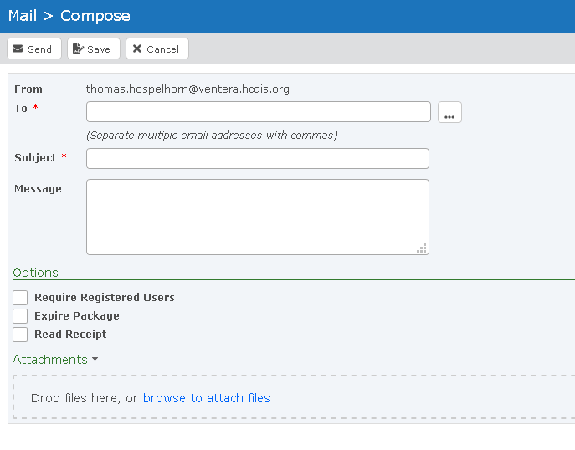

You will perform the same process as described on page 7 under the “Send To” section.
Note: Recipients of PHI / PII must be onboarded to MFT and senders may not utilize non-registered user option when sending PHI / PII.

Request Files
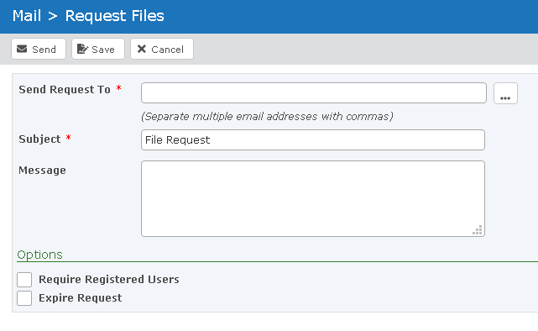
This function page allows you to specify a message that will be sent to one or multiple recipients containing a link where the recipient can upload files to you. Files that are uploaded will be sent as a package to your inbox. This is completed using a similar process as composing a message.

Drafts
Any messages that were saved while composing them will appear here.
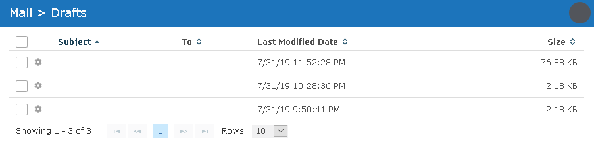

Templates
Templates can be used to set up a message and / or distribution list that can be used repeatedly.
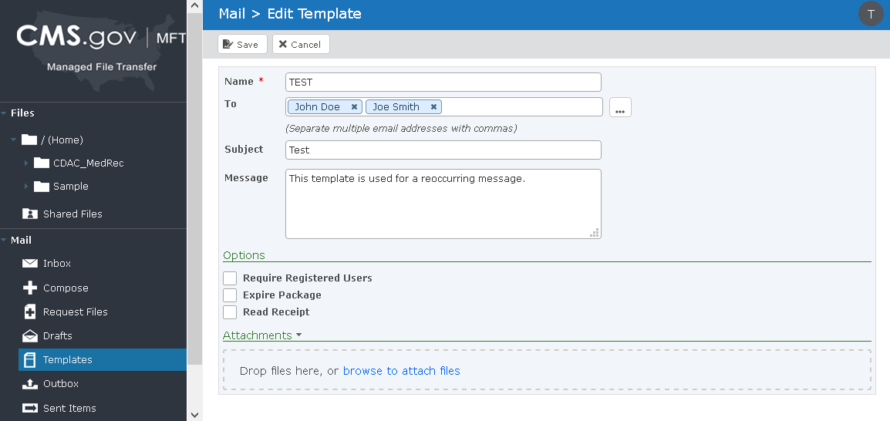
Once the fields are populated, enter a name for the template and save it.
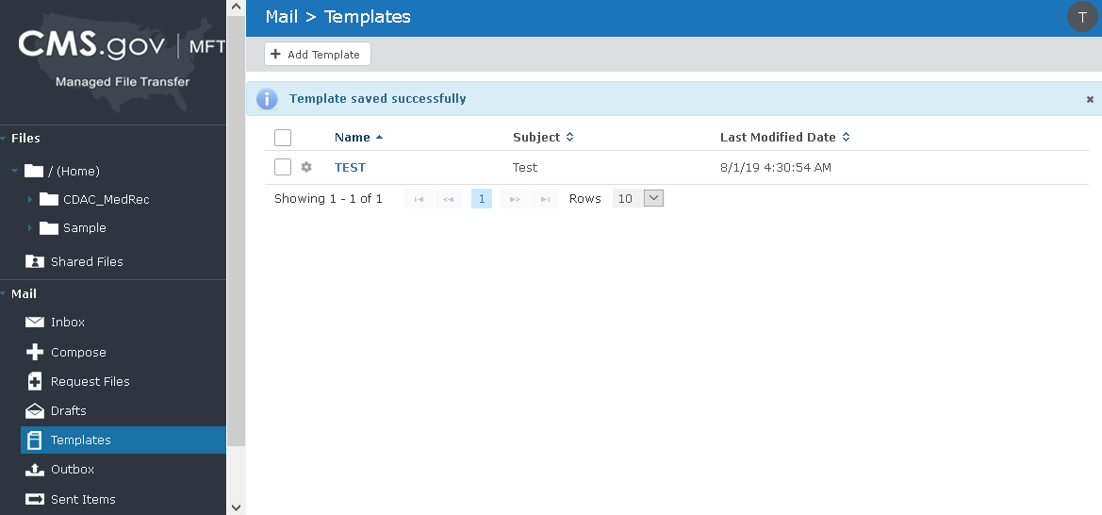

Outbox
The outbox will contain any messages that are in process from you but have not yet been transmitted.
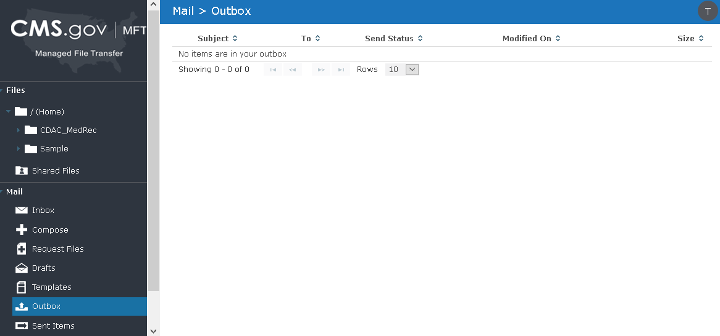

Sent Items
The outbox will contain any messages that you have previously sent.
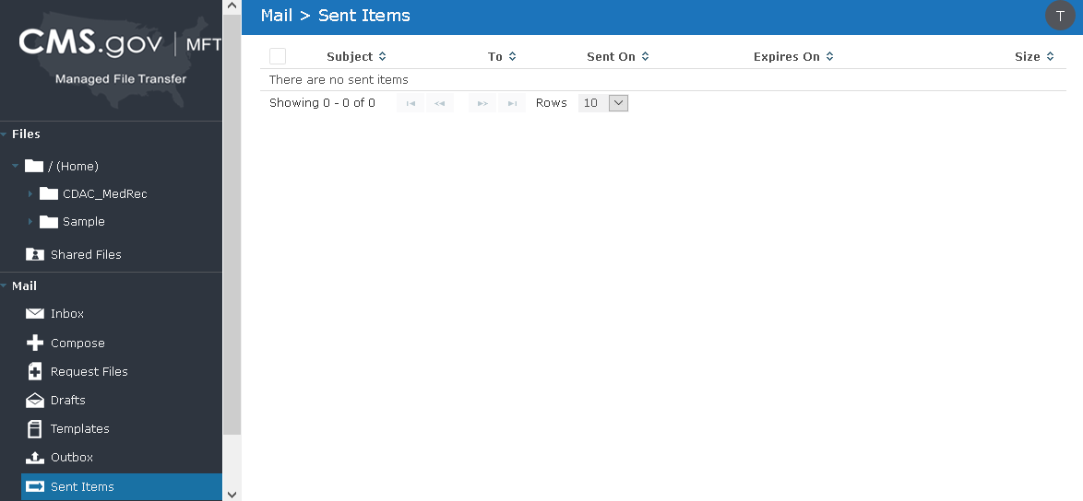

File Size
If you have a file in excess of 2 GB, you must use either Firefox or Chrome, which have been identified as having a threshold of about 40 GB. Internet Explorer and Microsoft Edge have thresholds of 2 GB and under and files attempted to be transferred through these browsers in excess of 2 GB will not be processed. There are no known constraints on the number of attachments, except for the total cumulative size of the files applies as referenced above.

