MFT WORK REQUEST PROCESS GUIDE

For Custom MFT work or enhancement requests, all users will need to submit requests by filling out a form via Slack channel #mft-requests
1. Click on the thunder “icon”
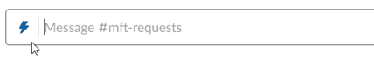
2. Choose 'MFT request'
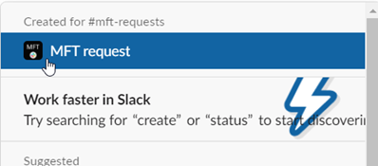

3. Choose option “MFT Customization” and fill out all fields on the form
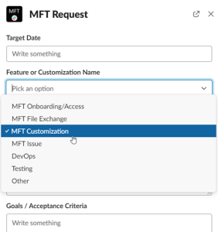

4. Click Submit and Continue
