MFT Work or Enhancements Request Process Guide

MFT WORK REQUEST PROCESS GUIDE

For Custom MFT work or enhancement requests, users will need to submit requests by completing the MFT Secure Form "MFT Request Form". This Secure Form allows users to submit requests/enhancements for the MFT application.
1. Log into MFT using your HARP credentials: https://qnetmft.cms.gov
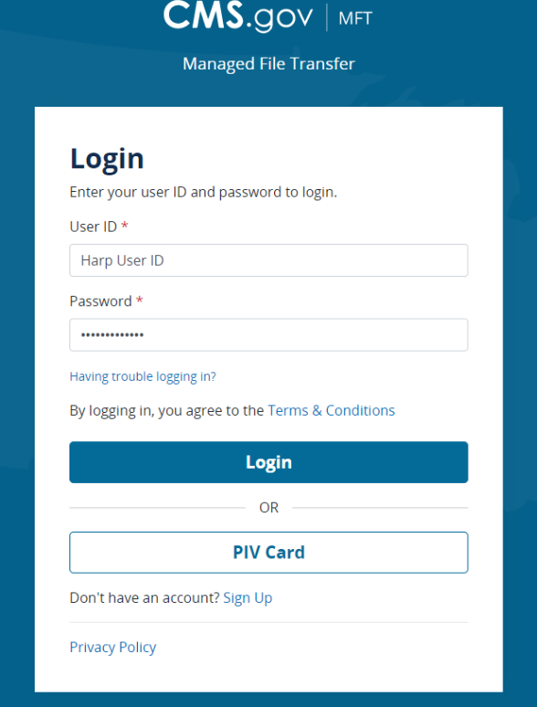

2. Choose 'Available Forms' and then MFT Request Form
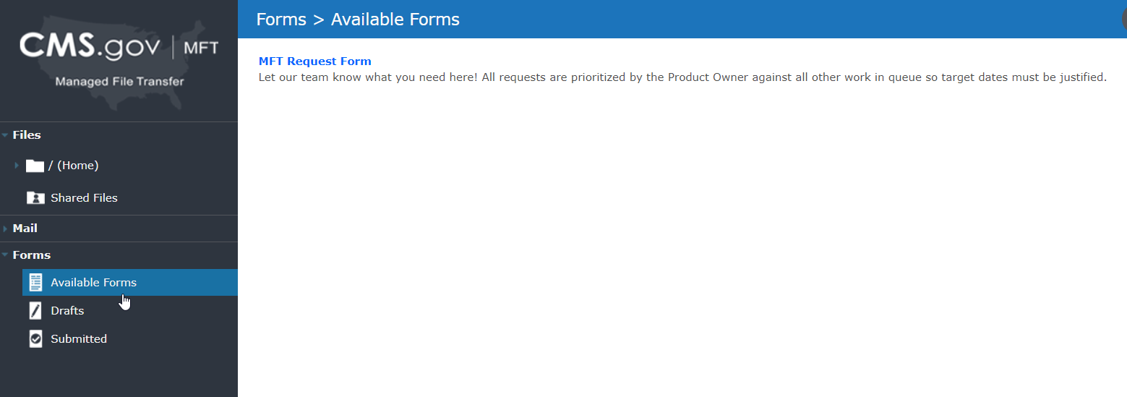

3. Fill out all fields on the form and then click Submit
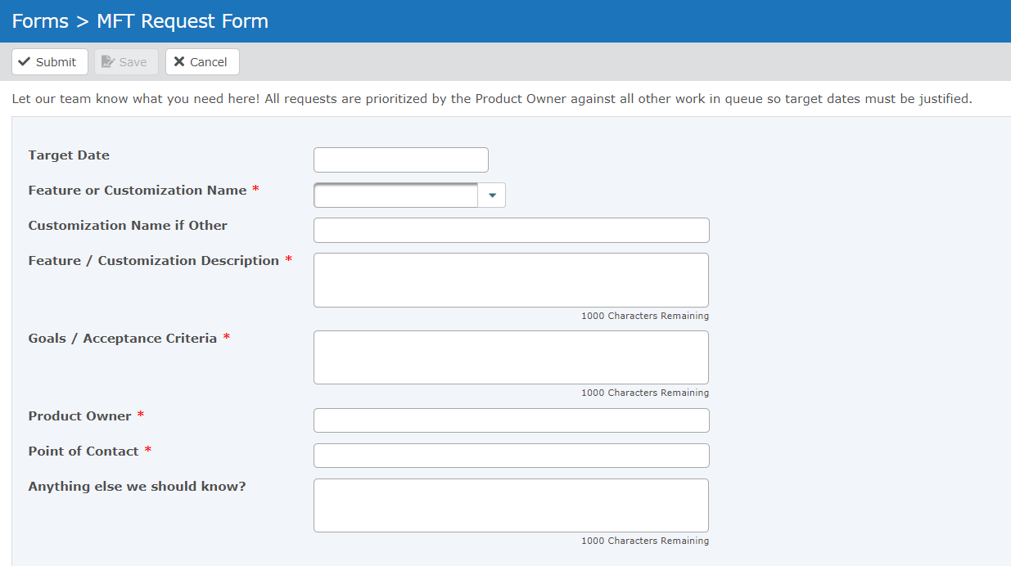

4. A JIRA Ticket is assigned, and work prioritized.

