Centers for Medicare & Medicaid Services

FileCloud v20.1
User Guide
Version 2.0
07/06/2020
Document Number: HIDS-000-056
Contract Number: HHSM-500-2015-00252C

Table of Contents
1. User Access 1
1.1 Pre-requisites 1
2. Accessing FileCloud from Web Browser 1
3. Creating Folders 4
4. Uploading Files 8
4.1 Drag and Drop from Windows Explorer 8
4.2 Via the Upload Button 9
5. Other FileCloud Tasks 11
5.1 Move File 12
5.2 Copy File 13
5.3 Delete File 15
5.4 Lock File 15
5.4.1 Locking Overview 15
5.4.2 Locking a File or Folder 16
5.4.3 Viewing Locked Files and Folders 18
5.4.3.1 To Filter User Locks 18
5.4.4 Unlocking a File or Folder 18
5.4.4.1 Administrator 18
5.4.4.2 Lock Owner 19
5.5 User Notification 19
5.5.1 Customize Notifications in User Settings 19
5.5.2 Disable custom notifications for a file or folder without removing custom settings…………………….. 19
5.5.3 Return to the default Notifications Settings 19
5.6 File Share 20
5.7 Preview a File in the User Dashboard 21
6. Dashboard Navigation 23
7. User Session Expiration 24
7.1 Default Behavior 24
8. FileCloud Drive 24
Appendix A: Record of Changes 26
Appendix B: Acronyms 27

List of Figures
Figure 1: FileCloud Login Page 2
Figure 2: FileCloud Main Dashboard 3
Figure 3: Main Dashboard – My Files and Team Folders 4
Figure 4: My Files Workspace 5
Figure 5: Contract Name Folder Workspace 5
Figure 6: Folder Actions Drop-down List 6
Figure 7: New Folder Window 6
Figure 8: Newly Created Subfolder 7
Figure 9: New Folder Workspace 7
Figure 10: Upload Queue Progress Window 8
Figure 11: Team Folder with Newly Uploaded File 9
Figure 12: Upload Button 9
Figure 13: Open Window 10
Figure 14: Upload Queue Progress Window 10
Figure 15: My Files Folder with Newly Uploaded File 11
Figure 16: More File / Folder Drop-Down Options 12
Figure 17: Move Files Window – Folder Selection 12
Figure 18: Move Files Progress Message 13
Figure 19: Copy Files Window – Folder Selection 13
Figure 20: Copy Window when Source and Destination Folders are the Same 14
Figure 21: Confirmation Message for Overwriting Existing File 14
Figure 22: Copy Files Progress Message 14
Figure 23: Confirm Delete Message 15
Figure 24: Delete Files Progress Message 15
Figure 25: Locking a File or Folder 16
Figure 26: Lock File Window 17
Figure 27: File/Folder Lock Indicator 17
Figure 28: Show Locks Selection 18
Figure 29: Lock Path 18
Figure 30: Unlock File or Folder 19
Figure 31: Show Options Selection 20
Figure 32: User Notification 20
Figure 33: Custom User Notification 20
Figure 34: Global Notification Settings 20
Figure 35: Preview Button 21
Figure 36: File Preview 22
Figure 37: FileCloud Help & Support Selection 23

List of Tables
Table 1: Lock Behavior 16
Table 2: Session Expiration 24
Table 3: FileCloud Server vs. Windows PC Using FileCloud Drive 25
Table 4: FileCloud Options for Files and Folders 25
Table 5: Record of Changes 26
Table 6: Acronyms 27

User Access
Follow the steps in this section to gain access to FileCloud (FC).

Pre-requisites
Before you can gain FileCloud access, you must have a HCQIS Access Roles & Profile (HARP) ID. Follow the steps in this section for obtaining a HARP ID.
- Register for a HARP ID. Below is the registration link as well as the link to video instructions. Please use your corporate email address in the Email Address field. If you already have a HARP ID, skip to step 2.
- Create your account using the following web site:
https://harp.qualitynet.org/register/
- The following video provides instructions on creating your account:
https://www.youtube.com/watch?v=G1zj8JqxWg4
- Once the HARP account has been created, log into HARP and request a FileCloud account via a HARP User Role.
- Select User Roles from the top of the page then select Request a Role.
- Select QualityNet-FileCloud and Next.
- Select your Organization and Next.
- Select a QualityNet-FileCloud user role (choose one).
- FileCloud-User
- FileCloud-SO (Account Administrator)
- The organization's Security Official reviews and approves/denies the user role request. You will be notified via email that your request has been submitted and again when your role has been approved or denied.
- Using your HARP credentials, log in to FileCloud at: https://filecloud.cms.gov
- If you have access to the HCQIS Confluence web site, you can find additional information about FileCloud here: https://confluence.hcqis.org/display/HS/FileCloud

Accessing FileCloud from Web Browser
Use the following steps to access FileCloud.
- From your computer, you may use any of the following web browsers:
- Google Chrome
- Mozilla Firefox
- Apple Safari
- Microsoft Internet Explorer
- Microsoft Edge
- Access the FileCloud Login page using the following web address: https://filecloud.cms.gov
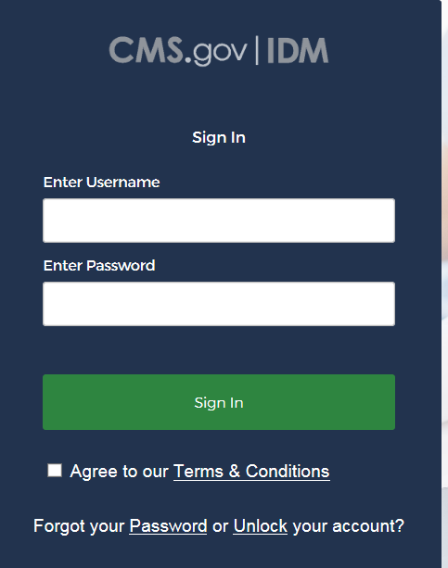
Figure 1: FileCloud Login Page
- In the Enter Username field, enter your HARP ID.
- In the Enter Password field, enter your HARP password.
- Put a checkmark in the box for “Agree to our Terms & Conditions.”
- Click the Sign In button.
- Upon a successful login, you will be redirected to FileCloud’s main dashboard page (Figure 2). From the dashboard, you will be able to navigate to both your personal space and your team folders.
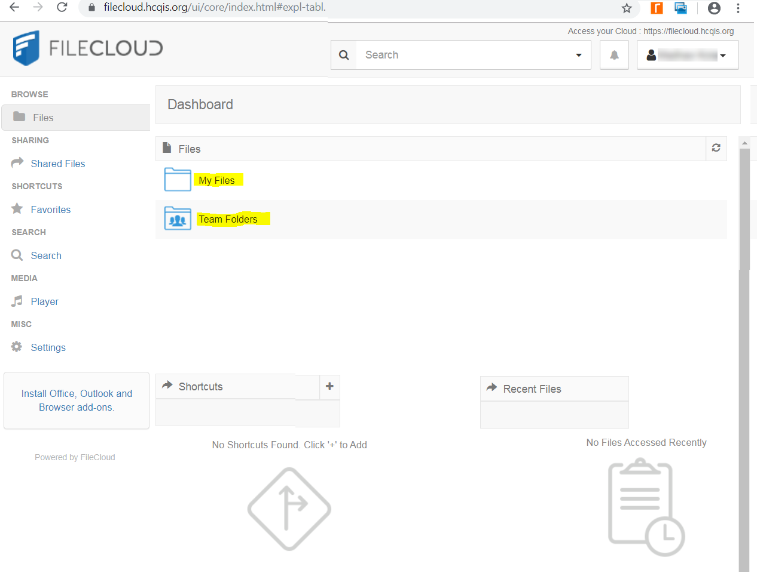
Figure 2: FileCloud Main Dashboard

Creating Folders
You can create subfolders within both My Files and Team Folders—see Figure 3.
NOTE: You cannot create an additional folder on the Dashboard.
- After you log in to FileCloud, you are at the main Dashboard. Click on either the My Files or Team Folders folder, or their links, to open the one where you want to create a subfolder.
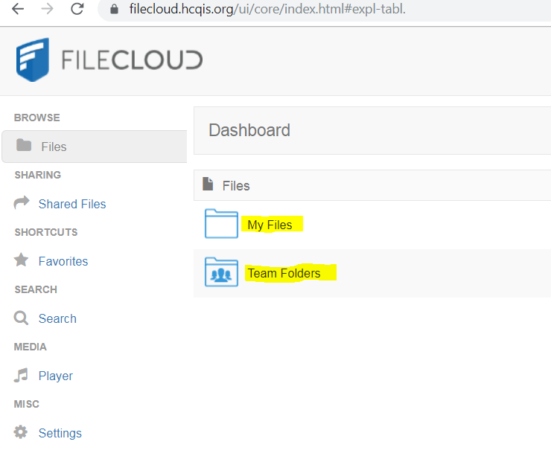
Figure 3: Main Dashboard – My Files and Team Folders
- Within the My Files folder, you will see the workspace where document files are stored—see Figure 4.
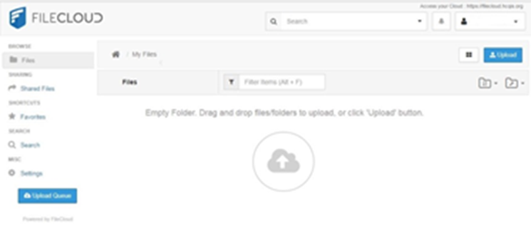
Figure 4: My Files Workspace
- Within the Team Folders folder, find your Contract Name Folder and click your Contract Name folder, or its associated link, see Figure 5. You will see the workspace where document files are stored.
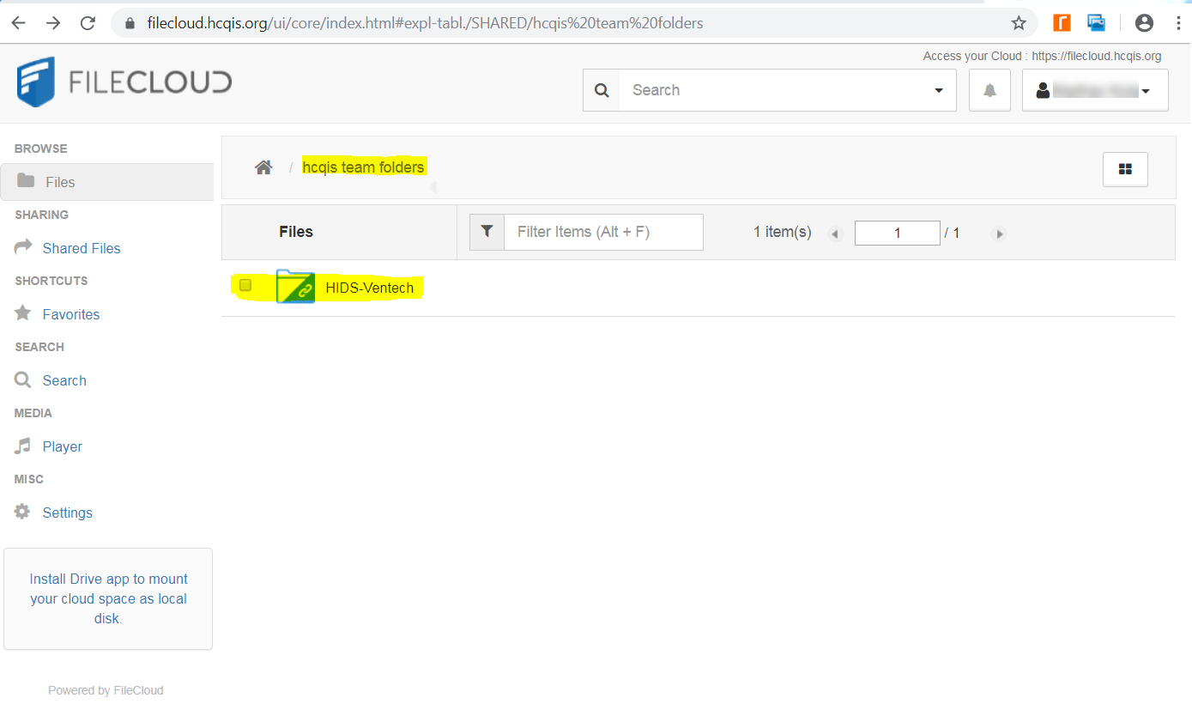
Figure 5: Contract Name Folder Workspace
- In the upper right corner, click the Folders Action icon 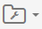 to open the Folder Actions drop-down list.
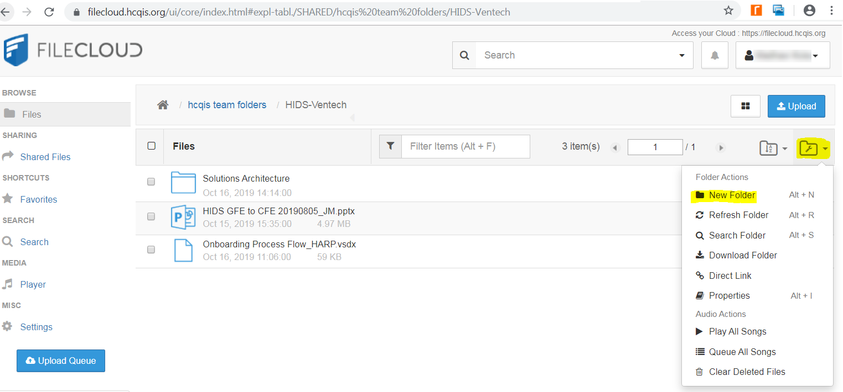
Figure 6: Folder Actions Drop-down List
- • Click New Folder in the drop-down list. The New Folder window displays (see Figure 7).
NOTE: You can also create new folders by right-clicking in the workspace and selecting New Folder from the drop-down menu.
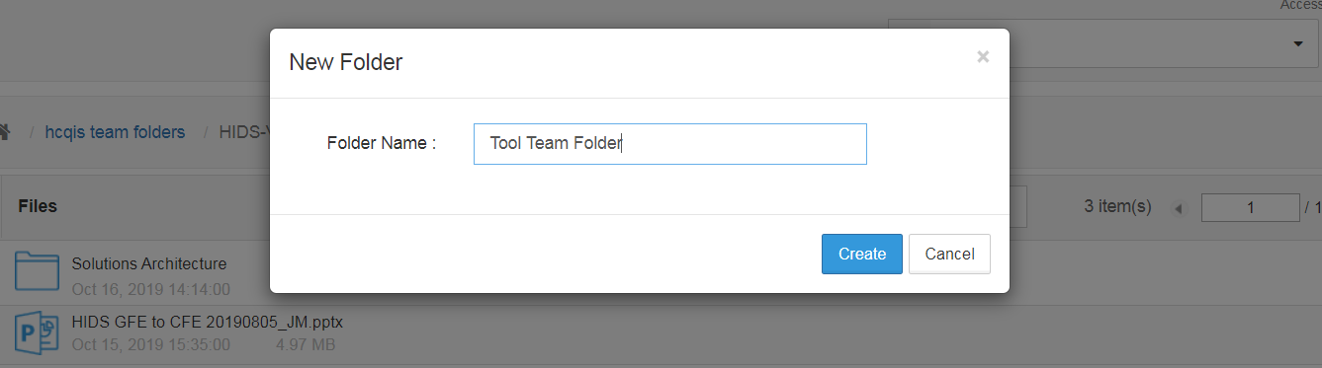
Figure 7: New Folder Window
- In the Folder Name field, enter the preferred name for the new folder then click the Create button (see Figure 7).
- The new subfolder displays within your folder—see Figure 8.
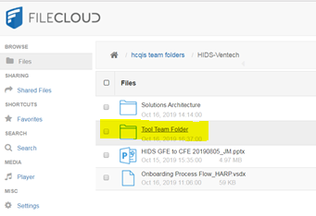
Figure 8: Newly Created Subfolder
- Click your new folder or its link. The folder workspace displays (Figure 9). You may begin uploading files to your new folder according to the directions in the next section.
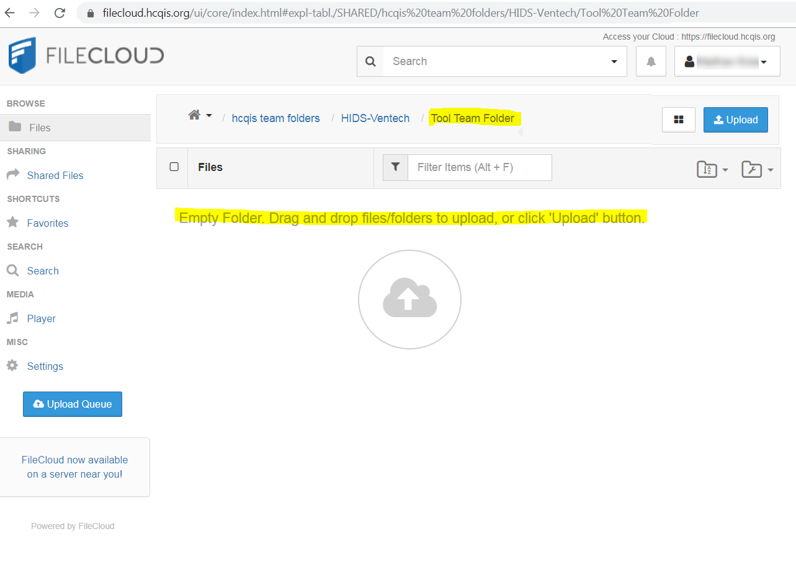
Figure 9: New Folder Workspace

Uploading Files
FileCloud allows you to upload files to a folder two ways:
- Drag and drop from Windows Explorer
- Via the Upload button

Drag and Drop from Windows Explorer
To drag and drop your file(s) into a FileCloud folder, perform the following steps.
- Make sure FileCloud is opened at the workspace for the folder where you want to upload the file.
- Open Windows Explorer and locate the folder where your file resides.
- Click on the file in Widows Explorer and drag it to the FileCloud folder.
- The Upload Queue window displays—see Figure 10.
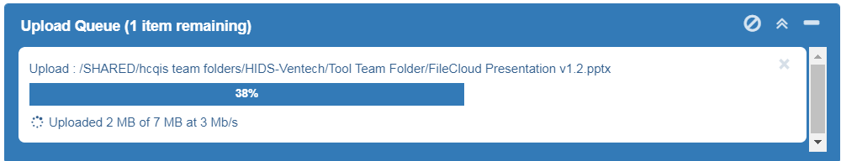
Figure 10: Upload Queue Progress Window
- Once the Upload Queue window reaches 100%, it closes automatically and your file displays in the FileCloud folder-see Figure 11.
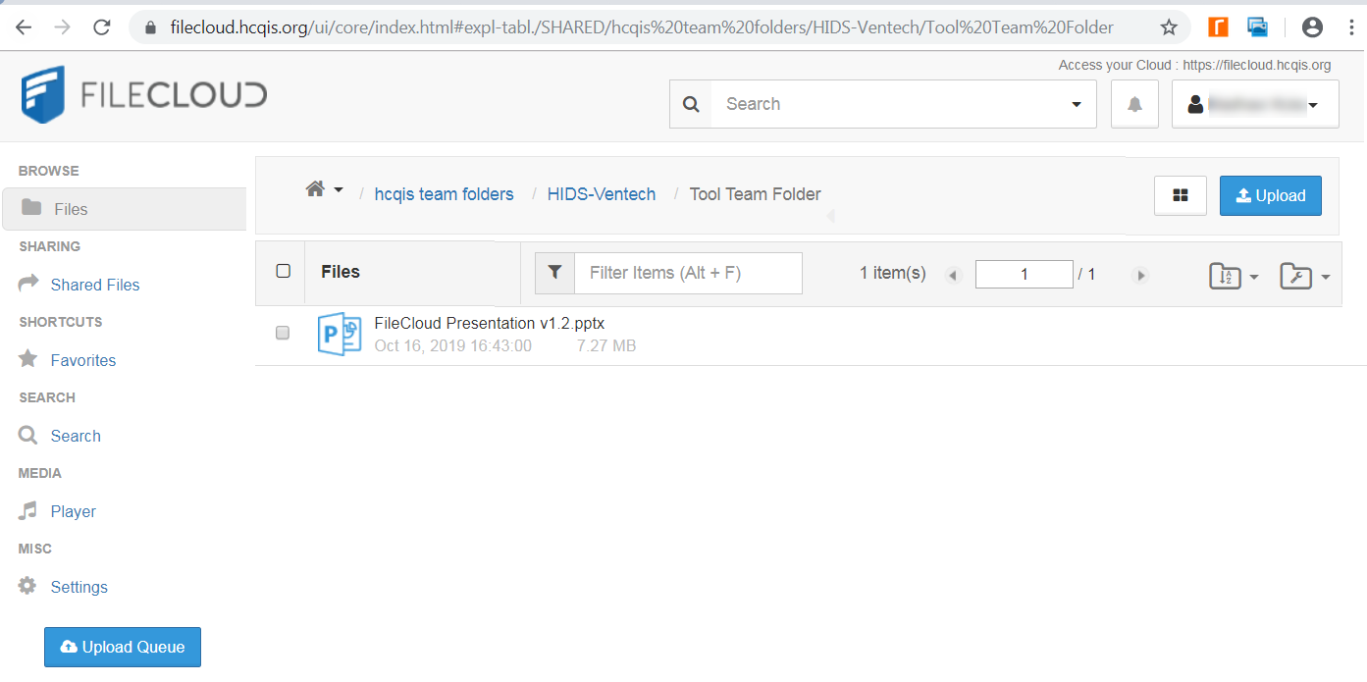
Figure 11: Team Folder with Newly Uploaded File

Via the Upload Button
If you want to use the Upload button to upload files, follow these steps.
- Click the Upload button on the upper right side of the screen.
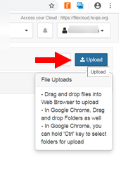
Figure 12: Upload Button
- This opens a Windows Explorer window where you can choose the file you want to upload.
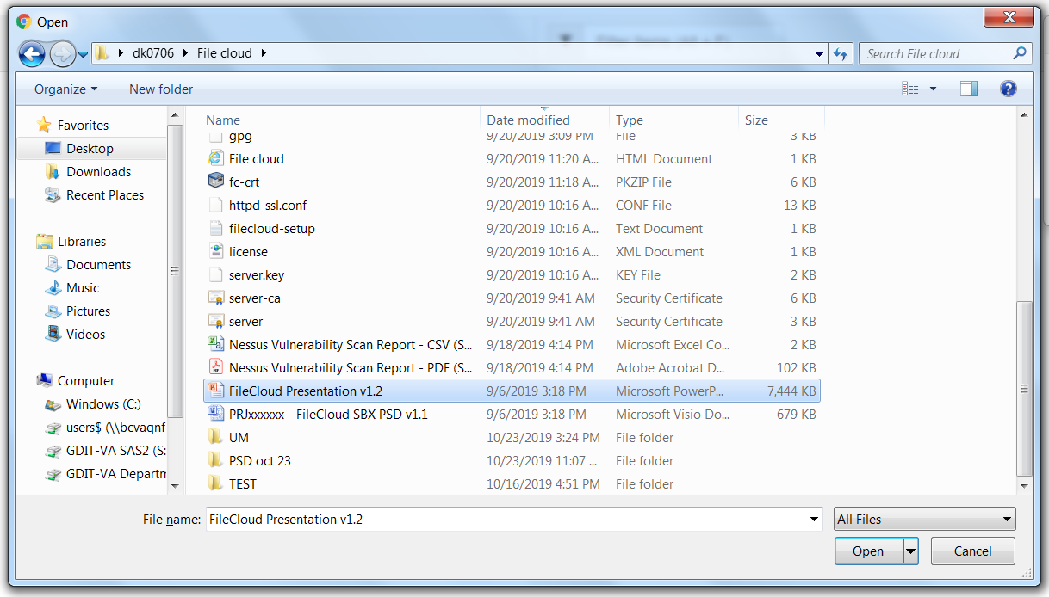
Figure 13: Open Window
- Highlight the file you want to upload and click the Open button in the lower right.
- The Upload Queue window displays to show the upload progress for the file.
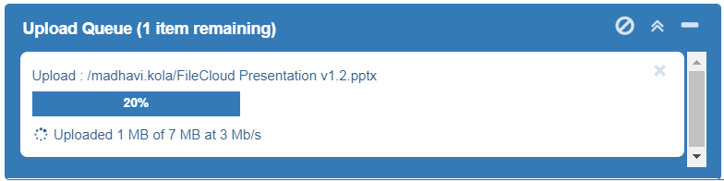
Figure 14: Upload Queue Progress Window
- Once the Upload Queue window reaches 100%, it closes automatically and your file displays in the FileCloud folder.
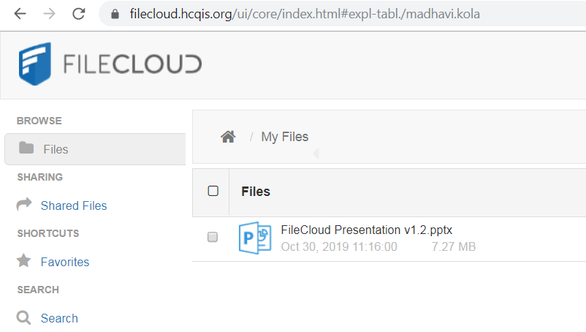
Figure 15: My Files Folder with Newly Uploaded File

Other FileCloud Tasks
To Move, Copy, or Delete a folder or file, perform the following steps.
- Click the file or folder that you wish to move, copy, or delete. The file/folder is highlighted after you click on it.
- Click the More drop-down above the file or folder, and the File Options drop-down menu displays—see Figure 16.
NOTE: You can also display the File Options drop-down menu by right-clicking on the file/folder.
- Select Move, Copy, or Delete from the File Options drop-down menu.
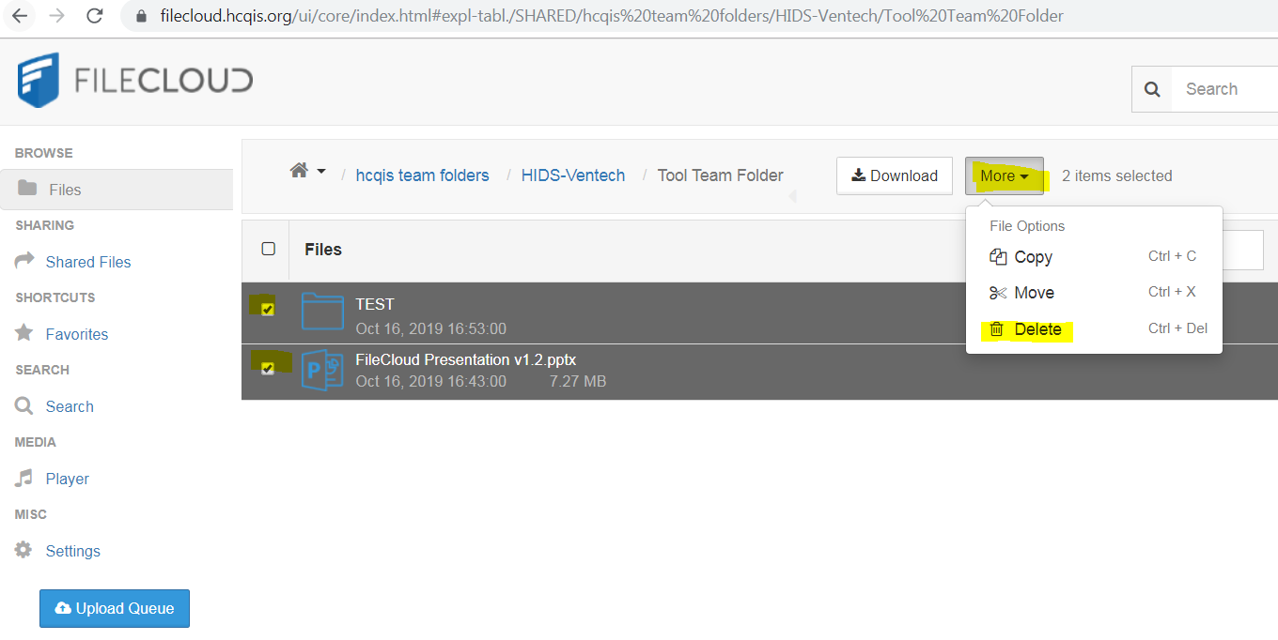
Figure 16: More File / Folder Drop-Down Options
For the remaining steps, follow the appropriate subsection depending on whether you are moving, copying, or deleting a file.

Move File
To move a file from one location to another, do as follows.
- When you choose the Move selection from the File Options drop-down, the following window appears.
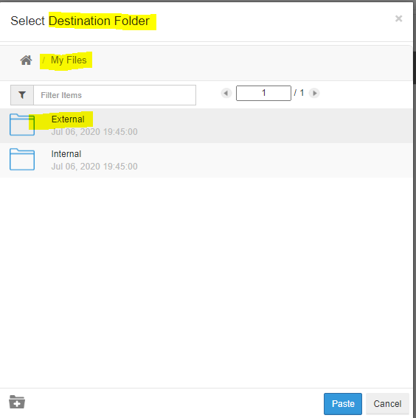
Figure 17: Move Files Window – Folder Selection
- Highlight the folder to which you want to move the file. This is the destination folder.
- Click the Select button.
- A message displays showing you the progress.
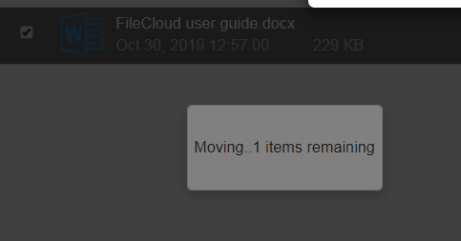
Figure 18: Move Files Progress Message
- When the move is complete, the message clears. The file is removed from the source folder and appears in the destination folder.

Copy File
To copy a file from one location to another, follow these procedures.
- When you choose the Copy selection from the File Options drop-down, the following window appears.
Figure 19: Copy Files Window – Folder Selection
- Highlight the folder to which you want to move the file. This is the destination folder.
- Click the Paste button. The next window appears.
- If the source and destination folders are different, the copy begins. Go to step 4.
- If the source and destination folders are the same, the following window appears.
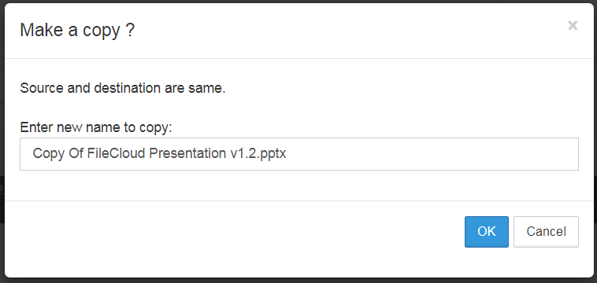
Figure 20: Copy Window when Source and Destination Folders are the Same
You have the choice of keeping the same file name or changing it by making a new entry in the “Enter new name to copy” box. Click OK to continue. If you changed the file name, the copy will begin — go to step 4. If you kept the same name, the following confirmation question displays letting you know you will be overwriting the existing file.
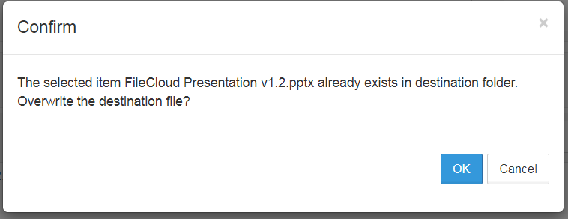
Figure 21: Confirmation Message for Overwriting Existing File
Click OK to start the copy— go to step 4.
- When the copy starts, a message displays showing you the progress.
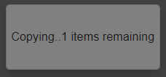
Figure 22: Copy Files Progress Message
- When the copy is complete, the message clears. The file stays in the source folder and a copy appears in the destination folder.

Delete File
The following steps instruct you on deleting a file.
- When you choose the Delete selection from the File Options drop-down, the following window appears.
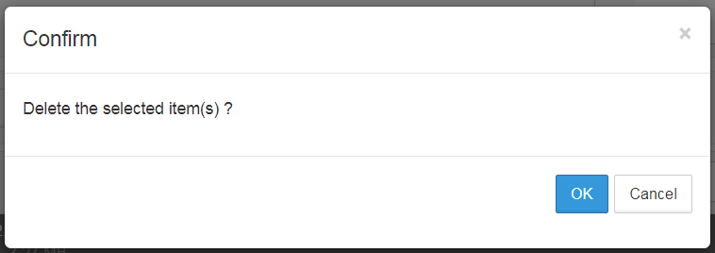
Figure 23: Confirm Delete Message
- Click OK to confirm that you want to delete the file. The following window appears to show you the progress.
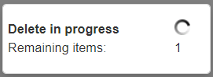
Figure 24: Delete Files Progress Message
- When the process is complete, the message clears and the file is removed from the folder.

Lock File

Locking Overview
Locking is available for both files and folders and signifies that you are actively using that file or folder. If you lock a file/folder, you are still able to access it but other users are prevented from accessing it.
When a file or folder is locked:
- A lock icon is shown in the file listing.
- The owner of the lock is shown in the details panel on the right-hand side.
- The owner of the lock has full access to that file or folder and can modify it.
- A lock can be set up to prevent reads by other users. In that case, other users cannot download or view the locked file or folder.
- Only the user who locked the file can permanently edit it. Any changes made by users with read-only permissions are not saved.
The following table shows the behavior depending on the type of lock.
Table 1: Lock Behavior
Lock with read allowed | Access by lock owner | Access by others
Yes | Full access to the file is available. Share/Sync/Edit/Deletes allowed | Only read is allowed. No modification is allowed
No | Full access to the file is available. Share/Sync/Edit/Deletes allowed | No access is provided . All access using all clients are blocked.

Locking a File or Folder
To lock a file or folder, use the following steps.
- Select the file or folder.
- In the More drop-down menu, select Lock.
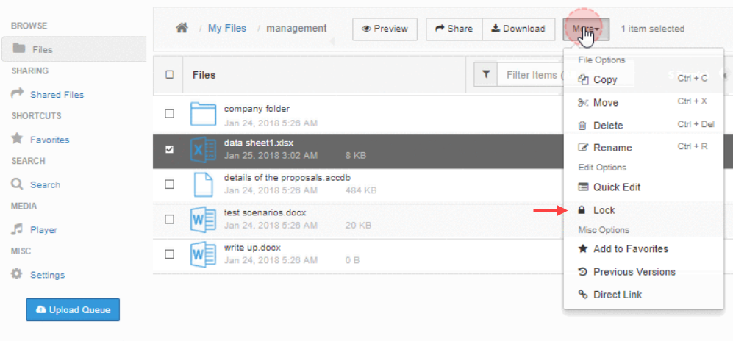
Figure 25: Locking a File or Folder
- Fill out the fields in the window that appears.
- Prevent others from downloading this while locked: Put a checkmark in this field to prevent all reads as well as writes to the file or folder. This is very restrictive in its behavior. If you do not put a checkmark in this field, then other users can view file/folder content but not modify it.
- Never Expires / Expires: If you choose Never Expires, the file/folder will be locked until you unlock it, as described in Section 5.4.4. If you choose Expires, the file will be unlocked automatically after the number of days you specify.
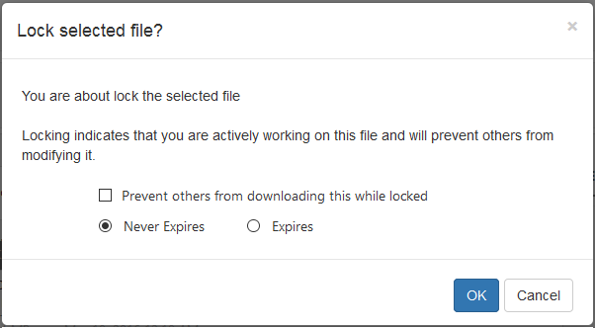
Figure 26: Lock File Window
- After filling out the window, click OK.
- A message will indicate if the lock is successful or not and a Lock icon will appear. Selecting the file or folder will also show the owner of the lock as well as the type of lock (Read allowed or not).
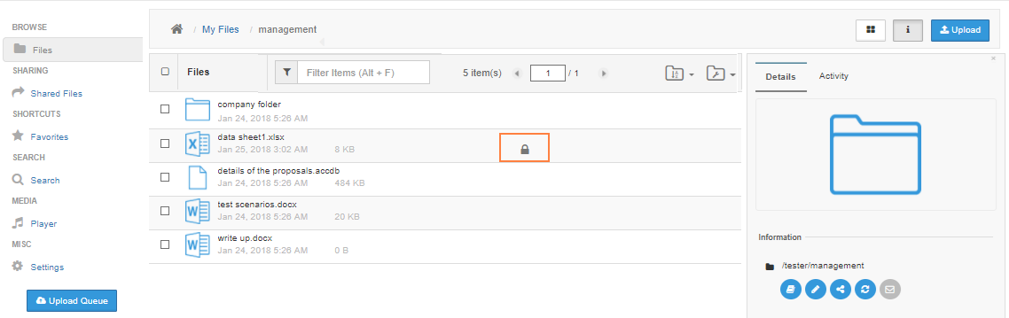
Figure 27: File/Folder Lock Indicator
At this point, all clients (Web Application, Cloud Drive, Cloud Sync, Mobile clients, WebDAV) will be subject to the lock restrictions. (Only the owner access using these clients is allowed.)
If a folder is locked, no files in that folder or its subfolder can be locked. Furthermore, none of the parent folder tree can be locked. (For example, for a folder structure of A_Folder/B_Folder/C_Folder/D_Folder, if “C_Folder” is locked by USER1, then none of A_Folder, B_Folder, D_Folder can be locked by USER2 until the lock of “C_Folder” is released.
To change a lock property (such as disallow read or change expiration), the lock has to be released and then the file/folder has to be re-locked.

Viewing Locked Files and Folders
To view all locks in the system via the web browser, do as follows.
- Click on the user account drop down button.
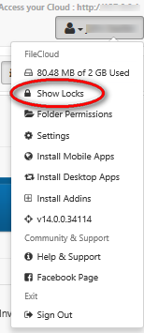
Figure 28: Show Locks Selection
- Click on Show Locks.

To Filter User Locks
To filter the locks view with respect to the lock path, type in the lock path in the “Filter” textbox.
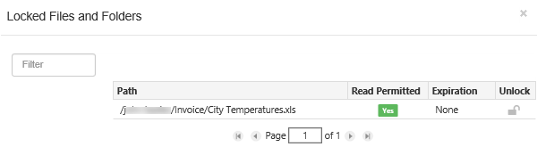
Figure 29: Lock Path

Unlocking a File or Folder
Once a file or folder is locked, it can be unlocked only by the owner of lock or by administrator.

Administrator
To unlock a file or folder as Administrator, read the article on Managing User Locks.

Lock Owner
If you are the user who locked the file/folder, use the following procedures to unlock it.
- Navigate to the page containing the file or folder.
- Select the file or folder.
- Under the More drop-down menu, select Unlock.
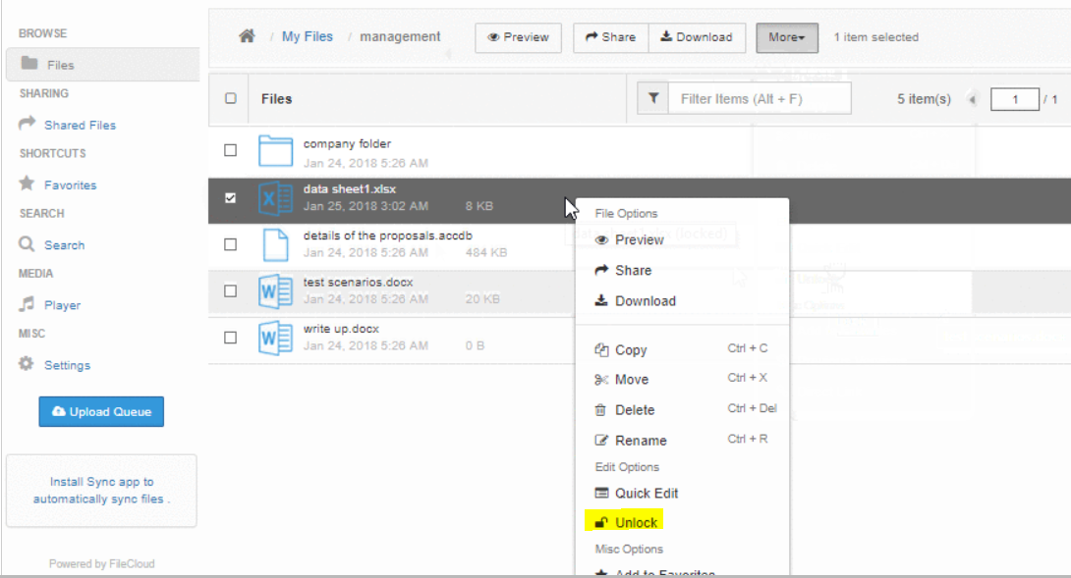
Figure 30: Unlock File or Folder
NOTE: Please call the QualityNet Help Desk if you need a file or folder unlocked and are not the owner of the lock.
QualityNet Help Desk
8 a.m. – 8 p.m. ET | Monday – Friday
qnetsupport@hcqis.org | (866) 288-8912

User Notification
By default, email notifications telling you of any changes made to files within a folder are enabled. To disable them, do as follows.
- Select the folder.
- Click on the More button and choose Show Options.
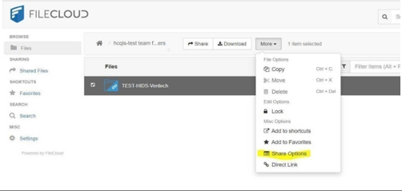
Figure 31: Show Options Selection
- In the Share Options screen, put a checkmark in the field, Disable File Change Email Notifications, and press the Save button.
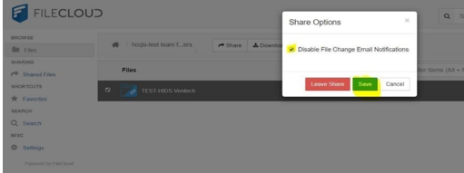
Figure 32: User Notification

Customize notifications in user settings

Customize notifications for a file or folder:
- In the user interface, navigate to the file or folder.
- Select the file or folder and either right-click it or click More in the toolbar:
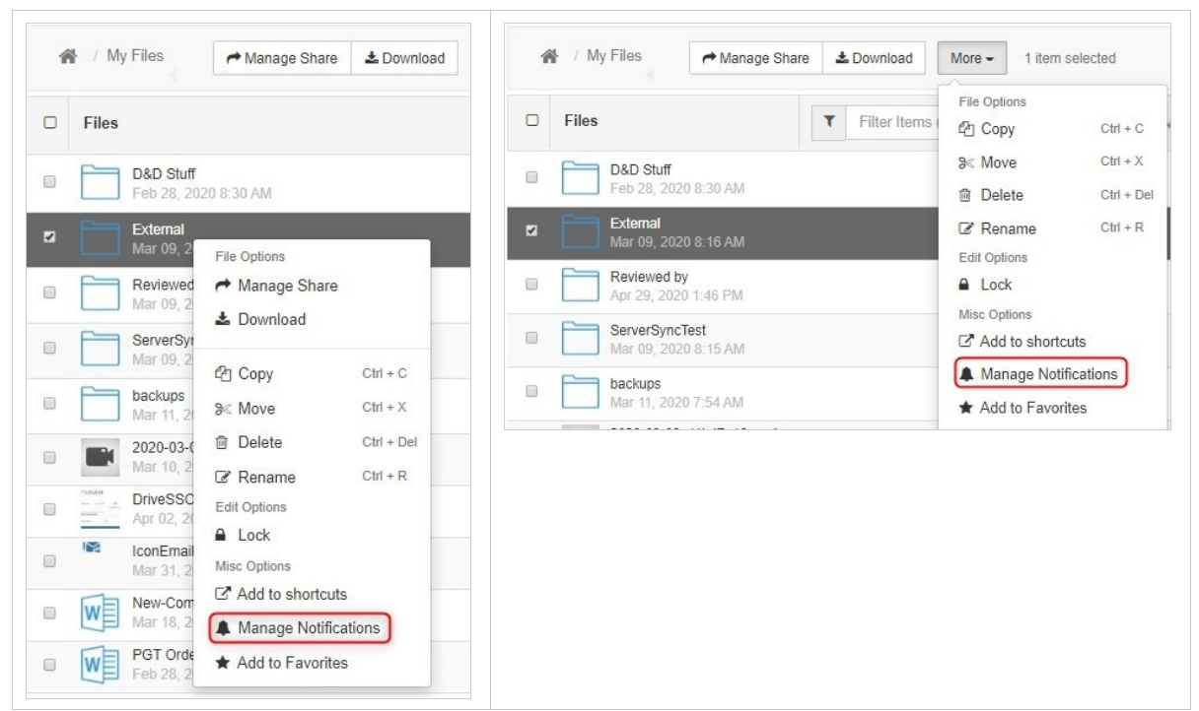
Figure 33: Custom User Notification

- To open a Notification Settings dialog box, choose Manage Notifications.
The first time you open the dialog box for a file or folder, nothing is checked or selected.
If you are permitted to override default settings, Use my own notification settings and all of the options under it can be edited. If you are not permitted to override default settings, Use my own notification settings and the options under it cannot be edited.
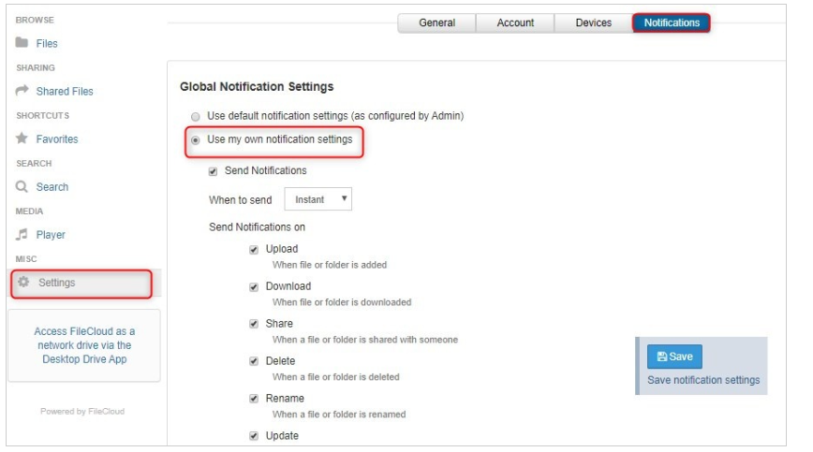
Figure 34: Global Notification Settings

- By default, Use default notification settings is selected.
If you are permitted to override default settings, Use my own notification settings and all of the options under it can be edited. If you are not permitted to override default settings, Use my own notification settings and the options under it cannot be edited.
- Select Use my own notification settings.
- To turn off notifications, uncheck Send Notifications; otherwise, leave it checked.
- By default, When to send is set to Daily.
If you want to receive notifications less frequently, choose Daily, Weekly, or Custom in the drop-down list. You will receive an email listing all new notifications since the last notification email.
If you choose Custom, a text box opens for you to enter the notification interval in minutes. You are not allowed to enter a value that is less than the notification interval set by your admin.
- Send Notifications on indicates which actions you will receive notifications about. All actions are unchecked by default.
Check any actions that you want to receive notifications about.
- Check Self Notifications if you want to receive notifications about changes you make to your own files or folders.

Note :
If you do not check Self Notifications, you only receive notifications when a user you have shared a file with performs an action on that file.
- If you do check Self Notifications, you also receive a notification when you perform an action on a file you own or a file that has been shared with you.

Disable custom notifications for a file or folder without removing custom settings:
- In the user interface, navigate to the file or folder.
- Select the file or folder and right-click it.
- Choose Manage Notifications.
- Uncheck Send Notifications.
- Click Save.

Return to the default notification settings
- In the user interface, navigate to the file or folder.
- Select the file or folder and right-click it.
- Choose Manage Notifications.
- Select Use default notification settings.
- Click Save.
If you want to return to your custom settings, you must reset them manually.

File Share
The share feature was disabled from the beginning per CMS and is not available in FileCloud due to security concerns. Sharing files from org to org in an ad hoc fashion is not permitted as CMS wants to be able to track any sharing. QualityNet Help Desk can reach for any ad hoc file sharing.

Preview a File in the User Dashboard
After you select a file in the User Portal, a Preview button is available.
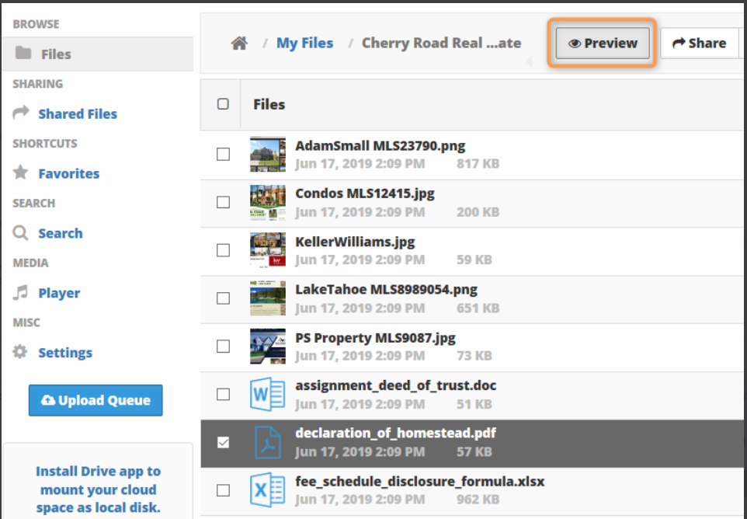
Figure 35: Preview Button
Click the Preview button to open a separate window showing a preview image of the file. You cannot edit the preview image.
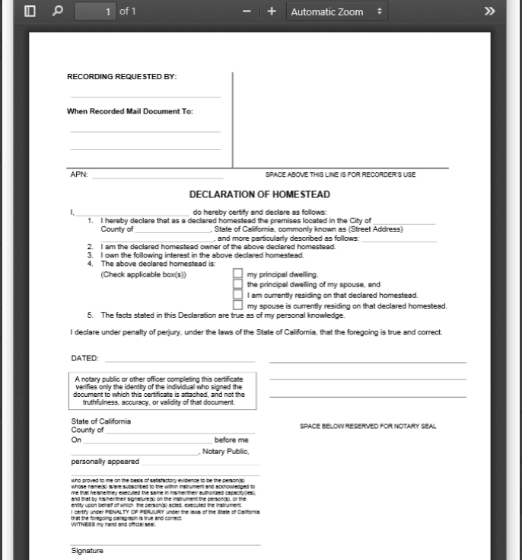
Figure 36: File Preview
FileCloud allows to view the following document types only via web browser:
- .AI
- .DICOM
- .DOC
- .DOCX
- .PDF
- .PPT
- .PPTX
- .PSD
- .XLS
- .XLSX

Dashboard Navigation
To learn more about dashboard navigation, use the following link to access the FileCloud User Guide:
https://getfilecloud.com/supportdocs/display/cloud/FileCloud+Server+User+Guide
To access FileCloud documentation within the FileCloud Web Application, perform the following steps.
- In the upper right corner, select the button with your User Name. The FileCloud drop-down displays, see Figure 35.
- Select Help & Support from the FileCloud drop-down list.
- A new browser tab will open with the full list of FileCloud Support Documentation.
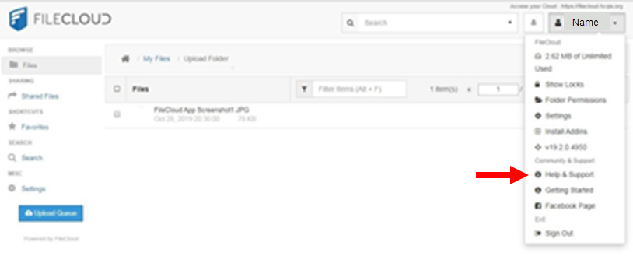
Figure 37: FileCloud Help & Support Selection

User Session Expiration

Default Behavior
By default, when a user logs in to FileCloud, his/her session remains authenticated for a specified amount of time.
Table 2: Session Expiration
Device | Time Session is Valid
Web Browser | Specified by the value in Session Timeout in days setting. If the browser is closed, the session expires.
All other apps and clients | Does not expire. Session lasts until user logs out from app.

NOTE: A user must close the browser in order to sign out (log out).

FileCloud Drive
You can use FileCloud Drive to store, access, and share files to collaborate with the people with whom you work and share data.
- FileCloud Drive is a client application. This is because it allows you to access the FileCloud Server and the files you store there.
- You can access files in Drive like you do on a Windows PC in Windows Explorer.
- The same features that are available on the User Portal are also available in Drive.
- Drive allows you to easily open the User Portal if you need to.
- Drive includes an assistant to make it easy to access Drive files from Microsoft applications.
- FileCloud Drive allows you to access all the files in your FileCloud server like you work with your files in Windows.
- Generally, we are used to working with Windows File Explorer, but changing to a web based user interface (UI) reduces efficiency. You have to download files from FileCloud first and then modify and upload it back to FileCloud. This can be improved when you work with FileCloud Drive. You can actually edit files the same way like you generally edit files on a Windows PC.

Table 3: FileCloud Server vs. Windows PC Using FileCloud Drive
This is how files are accessible on browser when it's on FileCloud Server | FileCloud Server looks like this in Windows PC using FileCloud Drive
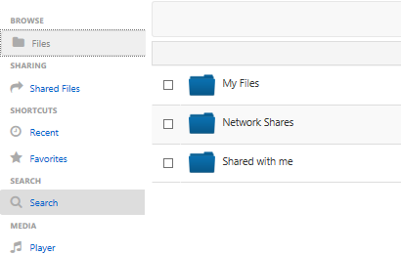 | 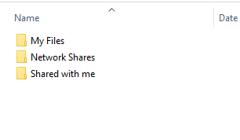

- You can access the following FileCloud options in Drive's Explorer window when you right-click on a file or folder:
Table 4: FileCloud Options for Files and Folders
Files | Folders
Share FileCloud Drive Link  View FileCloud Drive Properties | Share FileCloud Drive Link  Search FileCloud Drive Site  View FileCloud Drive Properties

You can find additional information for FileCloud Drive using the following link:
GOTO: Filecloud Drive

Please do not use the install or installation steps in the URL link above to install FileCloud Drive. Please use the FileCloud Drive installation guide to install FileCloud.
NOTE: Per CMS’s advice, “Allow Share” is not enabled; “Allow Upload” is enabled and should meet users’ needs.

- Record of Changes
Table 5: Record of Changes
Version | Date | Author/Owner | Description of Change
1.0 | 10/30/2019 | Ops-Tools Team | Initial version
1.1.4 | 02/25/2020 | Geoffrey Davenport/ OPS-Tools Team | Locking feature documentation; addition of QNet Help Desk info
1.1.4 | 03/11/2020 | Ops-Tools Team | Added instructions on File Share
1.1.5 | 04/10/2020 | Ops-Tools Team | Added instructions for File Preview
1.1.5 | 04/10/2020 | Ops-Tools Team | Added instructions for FileCloud Drive
2.0 | 04/15/2020 | Ops-Tools Team | New released version
2.1 | 07/08/2020 | Service Delivery & Collab team | New released version  -Added 5.5.1,2,3 Email Notification  -Updated Figures 17,18 33,34 Copy & Move dialog instructions available
- Acronyms
Table 6: Acronyms
Acronym | Definition
CMS | Centers for Medicare & Medicaid Services
FC | FileCloud
HARP | HCQIS Access Roles & Profile
HCQIS | Health Care Quality Information Systems
HIDS | HCQIS Infrastructure and Data Center Support
QualityNet Help Desk | Managed File Transfer
SO | Security Officer
UI | User Interface
URL | Uniform Resource Locator (web address)

