FILECLOUD DRIVE

You can use FileCloud Drive to store, access, and share files to collaborate with the people you work with or share data.

- FileCloud Drive is a client application. This is because it allows you to access the FileCloud Server and the files you store there.
- You can access files in Drive like you do on a Windows PC in Windows Explorer.
- The same features that are available on the User Portal are also available in Drive.
- Drive allows you to easily open the User Portal if you need to.
- Drive includes an assistant to make it easy to access Drive files from Microsoft applications.

What is FILECLOUD DRIVE
- FileCloud Drive allows you to access all the files in your FileCloud server like you work with your files in Windows.
- Generally, we are used to working with Windows File Explorer, but changing to a Web based UI reduces efficiency. You have to download files from FileCloud first and then modify and upload it back to FileCloud. This can be improved when you work with FileCloud Drive. You can actually edit files the same way like you generally edit files in Windows PC.

This is how our files are accessible on browser when it's on FileCloud Server. | FileCloud Server looks like this in Windows PC using FileCloud Drive.
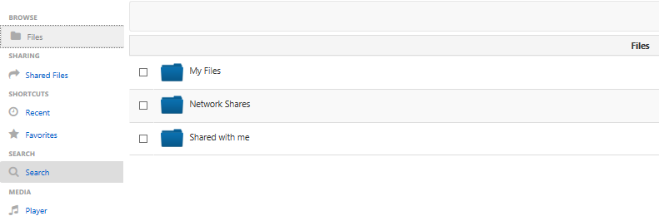 | 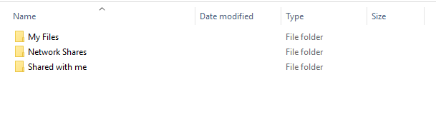

- You can access the following FileCloud options in Drive's Explorer window when you right-click on a file or folder:

Additional information for FILECLOUD DRIVE can be found on the following link
https://www.getfilecloud.com/supportdocs/display/cloud/FileCloud+Drive
Please do not use the install or installation steps on this URL link above to install FILECLOUD DRIVE. Please use the FILECLOUD DRIVE installation guide to install FILECLOUD

